1. Non-log plot

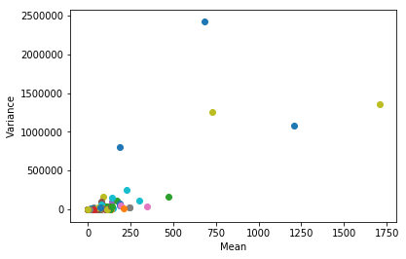

Limited the scope for a closer look

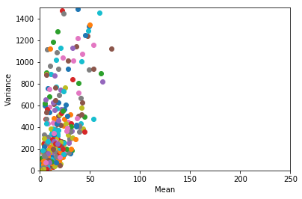

Log result, treating 0 as 0.00001, log(0.00001)= -11.5 (natural log) using the arithmetic mean:

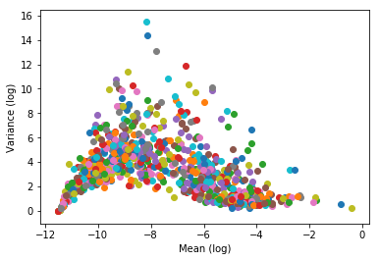

**OLS Regression Results**

**==============================================================================**

**Dep. Variable: y R-squared: 0.243**

**Model: OLS Adj. R-squared: 0.221**

**Method: Least Squares F-statistic: 11.20**

**Date: Tue, 10 Dec 2019 Prob (F-statistic): 3.29e-38**

**Time: 14:35:47 Log-Likelihood: 1517.8**

**No. Observations: 899 AIC: -2984.**

**Df Residuals: 873 BIC: -2859.**

**Df Model: 25**

**Covariance Type: nonrobust**

**==============================================================================**

**coef std err t P>|t| [0.025 0.975]**

**------------------------------------------------------------------------------**

**const 0.0437 0.002 25.261 0.000 0.040 0.047**

**x1 -0.0082 0.031 -0.262 0.793 -0.070 0.053**

**x2 -0.0109 0.043 -0.251 0.802 -0.096 0.074**

**x3 0.0664 0.029 2.270 0.023 0.009 0.124**

**x4 -0.0947 0.061 -1.555 0.120 -0.214 0.025**

**x5 -0.0156 0.049 -0.319 0.750 -0.111 0.080**

**x6 0.2262 0.043 5.202 0.000 0.141 0.312**

**x7 -0.0322 0.046 -0.706 0.481 -0.122 0.057**

**x8 0.6588 0.165 4.003 0.000 0.336 0.982**

**x9 0.1932 0.056 3.470 0.001 0.084 0.303**

**x10 -0.2210 0.136 -1.624 0.105 -0.488 0.046**

**x11 0.3420 0.044 7.821 0.000 0.256 0.428**

**x12 0.2030 0.113 1.793 0.073 -0.019 0.425**

**x13 0.0688 0.163 0.421 0.674 -0.252 0.389**

**x14 0.2348 0.098 2.393 0.017 0.042 0.427**

**x15 0.1478 0.102 1.451 0.147 -0.052 0.348**

**x16 0.0291 0.094 0.310 0.757 -0.156 0.214**

**x17 0.2740 0.116 2.371 0.018 0.047 0.501**

**x18 -0.1176 0.127 -0.926 0.354 -0.367 0.132**

**x19 -0.5839 0.228 -2.560 0.011 -1.032 -0.136**

**x20 -0.1589 0.224 -0.709 0.479 -0.599 0.281**

**x21 -0.0384 0.043 -0.887 0.375 -0.123 0.047**

**x22 -0.0190 0.073 -0.262 0.794 -0.161 0.123**

**x23 0.0310 0.034 0.903 0.367 -0.036 0.098**

**x24 0.0177 0.114 0.156 0.876 -0.206 0.241**

**x25 -0.6940 0.174 -3.999 0.000 -1.035 -0.353**

**==============================================================================**

**Omnibus: 1568.717 Durbin-Watson: 1.857**

**Prob(Omnibus): 0.000 Jarque-Bera (JB): 1658675.018**

**Skew: 11.233 Prob(JB): 0.00**

**Kurtosis: 212.227 Cond. No. 209.**

**==============================================================================**